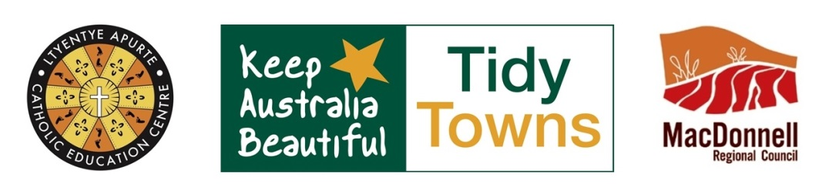
Ltyentye Apurte / Santa Teresa
TIDY TOWNS
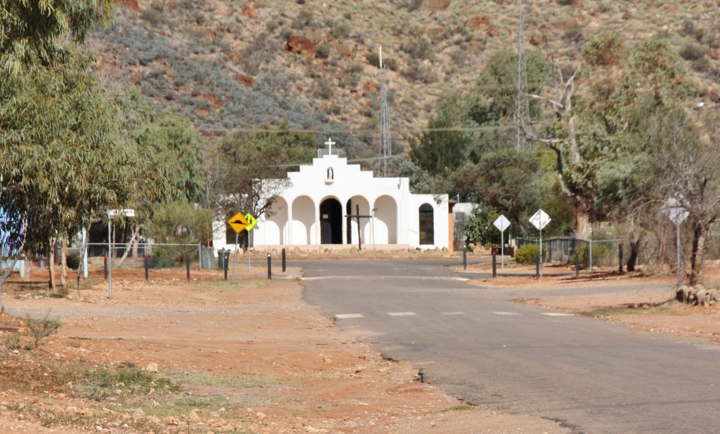
Werte everyone! Santa Teresa is a beautiful community but it has a problem with RUBBISH.

Ltyentye Apurte Catholic School and MacDonnell Regional Council are working together to improve our community. WE NEED YOUR HELP!

Look inside to see how. Thanks!

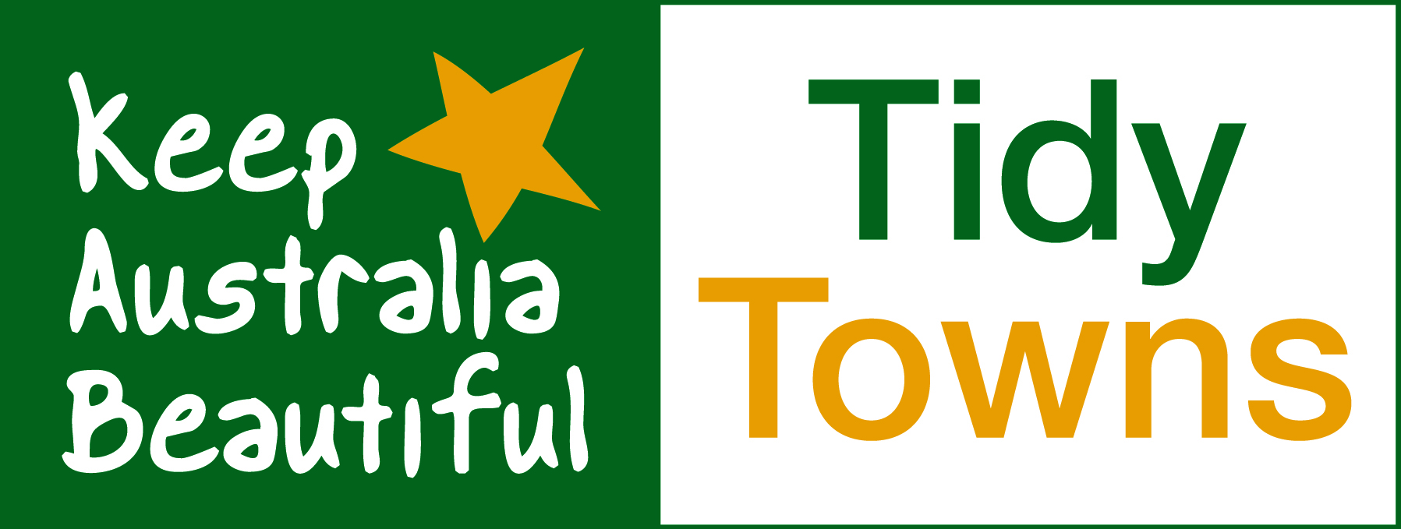
Ltyentye Apurte Catholic School and MacDonnell Regional Council are working with:

KEEP AUSTRALIA BEAUTIFUL – NT

They run the Tidy Towns competition. Each year, communities across the NT and Australia try to be more tidy and beautiful. This makes them nicer places to live.

Santa Teresa hasn’t won this competition for nearly 30 years. If other communities can do it, SO CAN WE !!!

2015 |  | WINNER |  | Mt. Liebig
2016 |  | WINNER |  | Areyonga
2017 |  | WINNER |  | ?
SANTA TERESA HAS A RUBBISH PROBLEM

LOOK HERE Nhenhe araye!
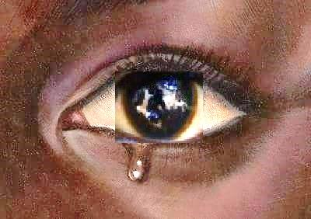

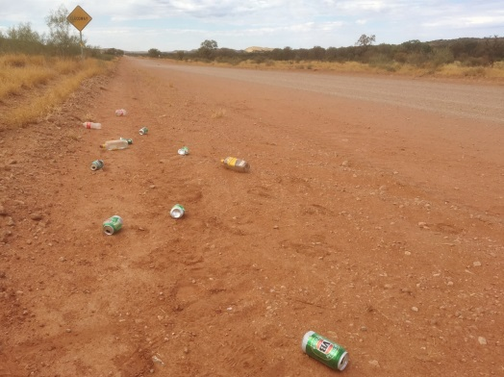
Alice Road to town

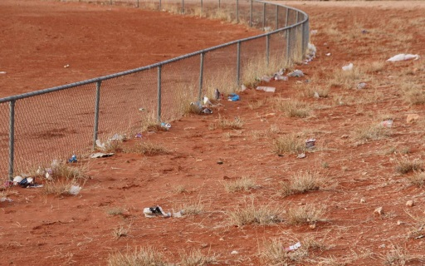
Old Village
Eastside
Beside the oval
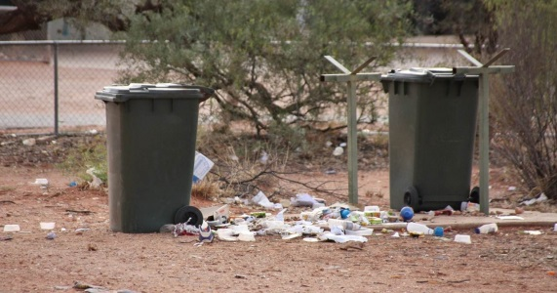
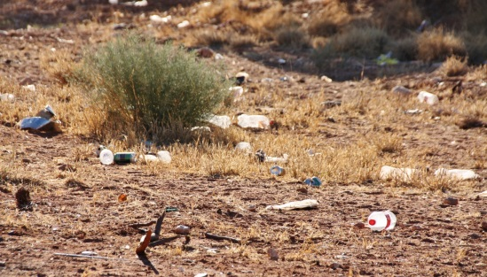
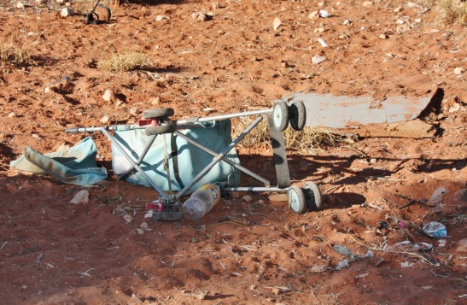
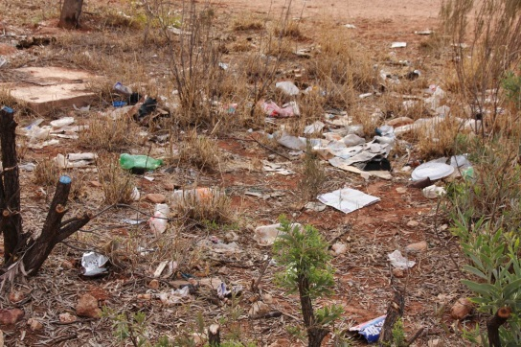
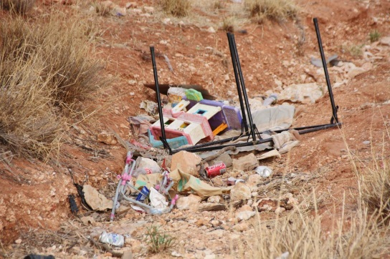
Eastside
New House
Alice Road
A Message To You From:

TRADITIONAL OWNERS

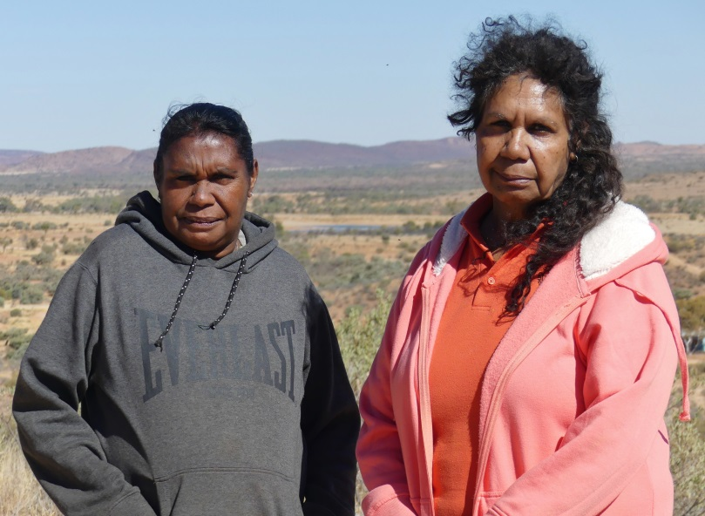

- Seeing rubbish lying around Ltyentye Apurte is sad and makes us feel no good.
- Dropping plastic, cardboard and tin everywhere is NOT Indigenous way.
- Ltyentye Apurte country used to be clean, tidy and natural.
- Now, the rubbish goes from the community – all the way along Alice Road – to the airport.
- If our Indigenous ancestors saw it they would be sad and shamed.
- It comes down to RESPECT... You owe it to the land, you were born here.
- There are bins everywhere, including around our homes. Please – for the sake of the land and our ancestors – put your rubbish in the bin.
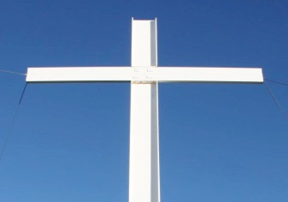 | A Message To You From:  PRIEST – Fr. BOSCO

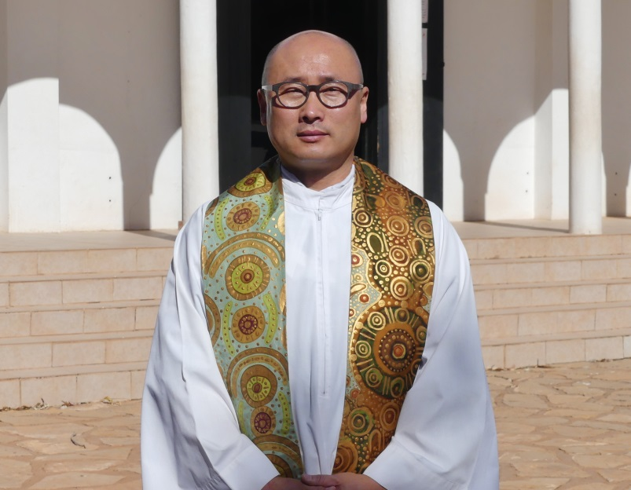

- In Genesis 2:15, it says, “The Lord God took the man and put him in the Garden of Eden to work it and keep it.” Here, our loving God tells us that we are carers of the earth and above all, we must keep it neat and tidy. Fact is – we don’t own the earth, God does. While we’re here, we simply care for it.
- It’s our responsibility to hand over the planet as best as possible for our children.
- ‘Creation’ is a gift from God. We must respect it, as we respect our bodies.
- All the rubbish lying around can harm our bodies. Every single one of us is affected by the environment. If it suffers, so do we.
- The country around Ltyentye Apurte is not just land. It’s the place where our ancestors lived. We must respect them too.
- Please… put your rubbish in the bin.
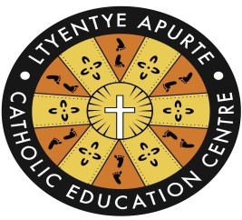 | A Message To You From:  THE SCHOOL

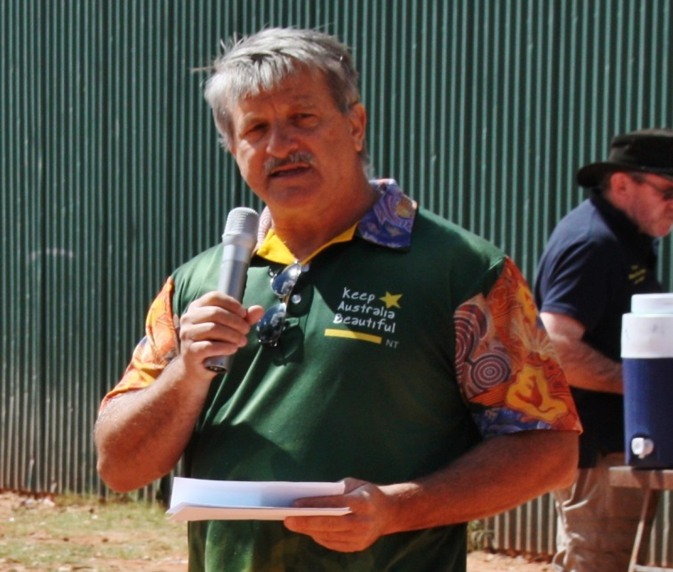

- Heimo Schober, CEO of Keep Australia Beautiful – NT, has taught your kids three things… dropping rubbish:
- Disrespects the land given to you by your ancestors.
- Makes people and children sick through spread of germs.
- Harms local animals and wildlife.
- In assembly we say, “We acknowledge the Arrernte people, who are the traditional custodians of this land.” This means that you are the ‘carers’ of this land. We remind your children of Aboriginal “Connection with Country” and what it means.
- It makes us sad to see so much rubbish lying everywhere. This is not caring for the land at all.
- Plastics, tin, cartons and glass can be RECYCLED.
- There’s NO SHAME in picking up rubbish. EVERYONE should be putting their rubbish in the bin. It’s the right thing to do.
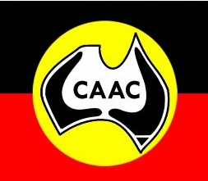 | A Message To You From:  THE HEALTH CENTRE

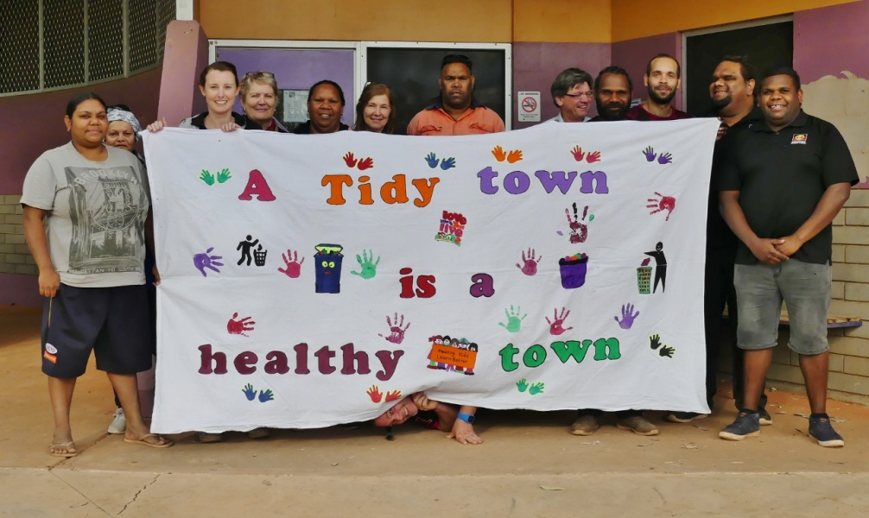

- Germs and parasites love rubbish and food scraps left lying around your house and garden. These germs and parasites can cause sickness like diarrhoea, anaemia (weak blood) and skin infections, which can lead to rheumatic heart disease and kidney disease.
- Sharp tins and broken bottles can cut people. These cuts can easily get infected and make people very sick.
- Rubbish and food scraps attract flies, cockroaches and mice to your house, which can also spread disease (diarrhoea, scabies, trachoma and other eye infections).
- You can stop people and children getting sick by:
- keeping yourself, your family and your house clean
- washing hands after going to the toilet, touching animals and before preparing and eating food
- Putting your rubbish in the bin.
HOW YOU CAN HELP:

1) Put your rubbish in the BIN.
Pick it up if you see it.

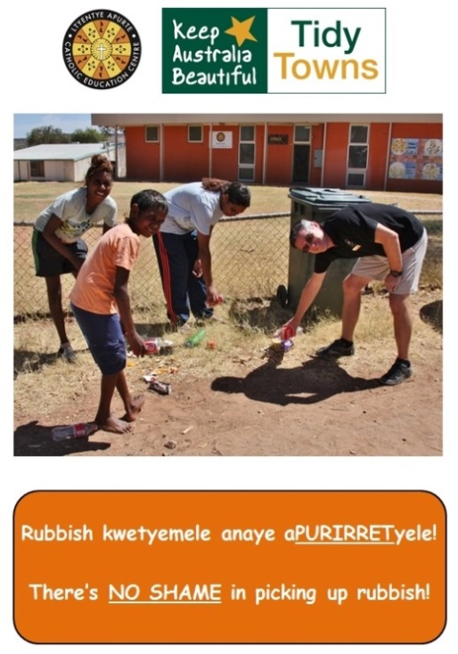
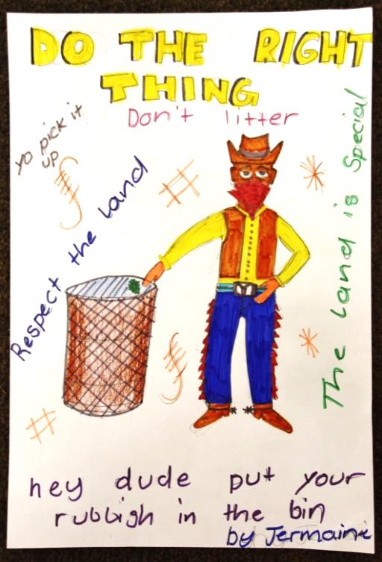

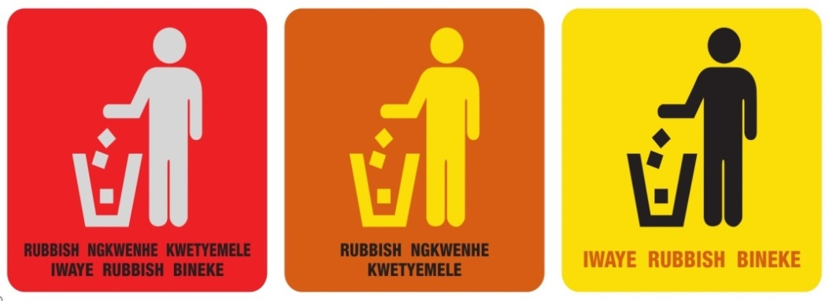
HOW YOU CAN HELP:

2) RECYCLE what you can.

Hey, you mob!
Wanna make some cash?

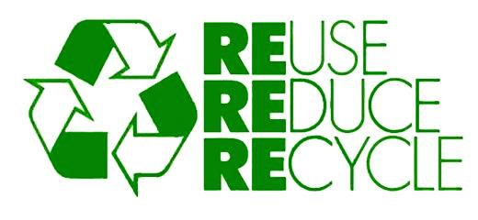
● You get 10c on everything you return. Take these to the Envirobank and get money back. Put them in Santa bins and the school or community get money back!
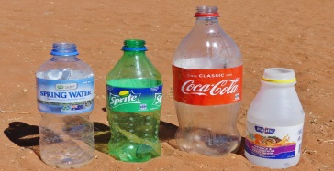 |  | 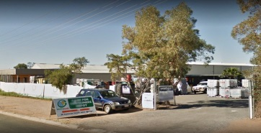
ENVIROBANK
39 Cameron Street, Alice Springs
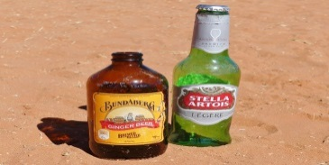 |  | 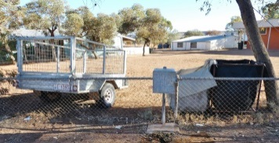
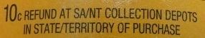 |  | LTYENTYE APURTE SCHOOL  Santa Teresa
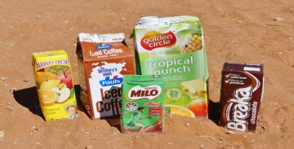 |  | 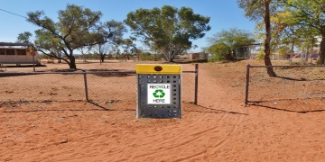
Top of ALICE ROAD
Santa Teresa
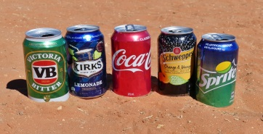 |  | 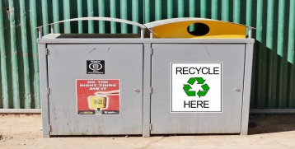
Outside the REC HALL
Santa Teresa
HOW YOU CAN HELP:

3) Join our Community Working Bees.

The school and council pick up rubbish together. But EVERYONE should be helping to Keep Santa Teresa Tidy! Look out for signs in the Store. When you see us – please join in.
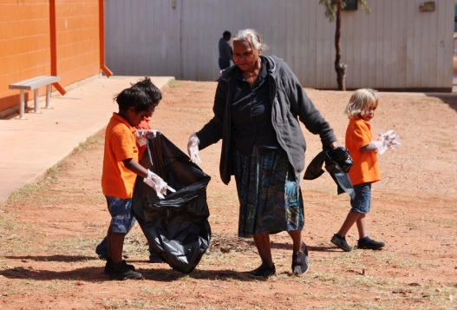
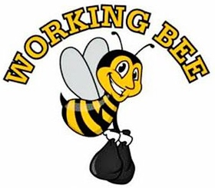
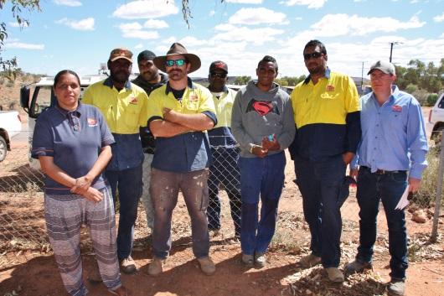

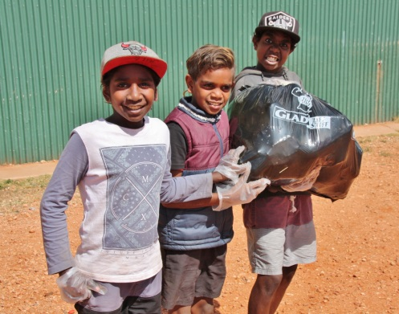
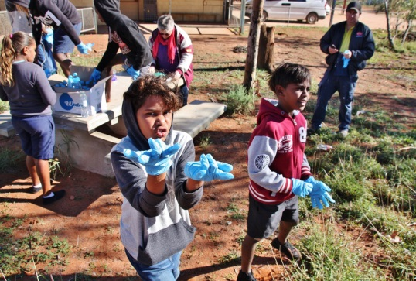
REMEMBER
For the sake of our ancestors, our God, our land, our children and everyone in Santa Teresa, PLEASE…

- Don’t throw your rubbish on the ground.

- Put your rubbish in the bin.

- Keep the area around your home clean and tidy.

- Recycle what you can.

- Help the school and council at Community Working Bees.
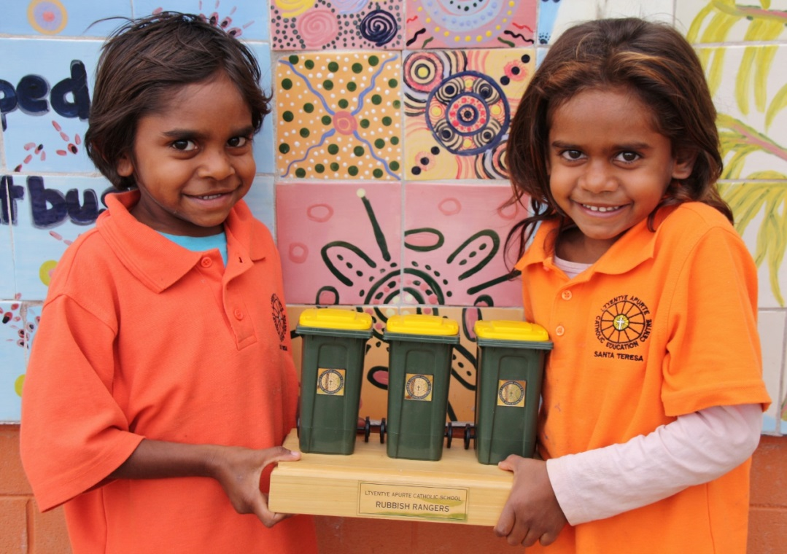
Ltyentye Apurte’s future…

KEEP SANTA TIDY for them!

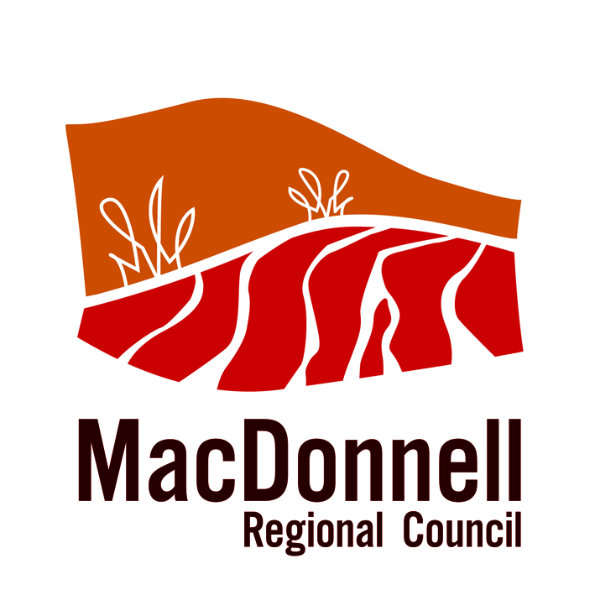 | Ltyentye Apurte Catholic School and Keep Australia Beautiful – NT are grateful to MacDonnell Regional Council for printing this community education pamphlet. Kele!  Justin Colley Annalisa Young Sam Ashton (July 2017)

