MEDIA RELEASE
15 Feb 2017

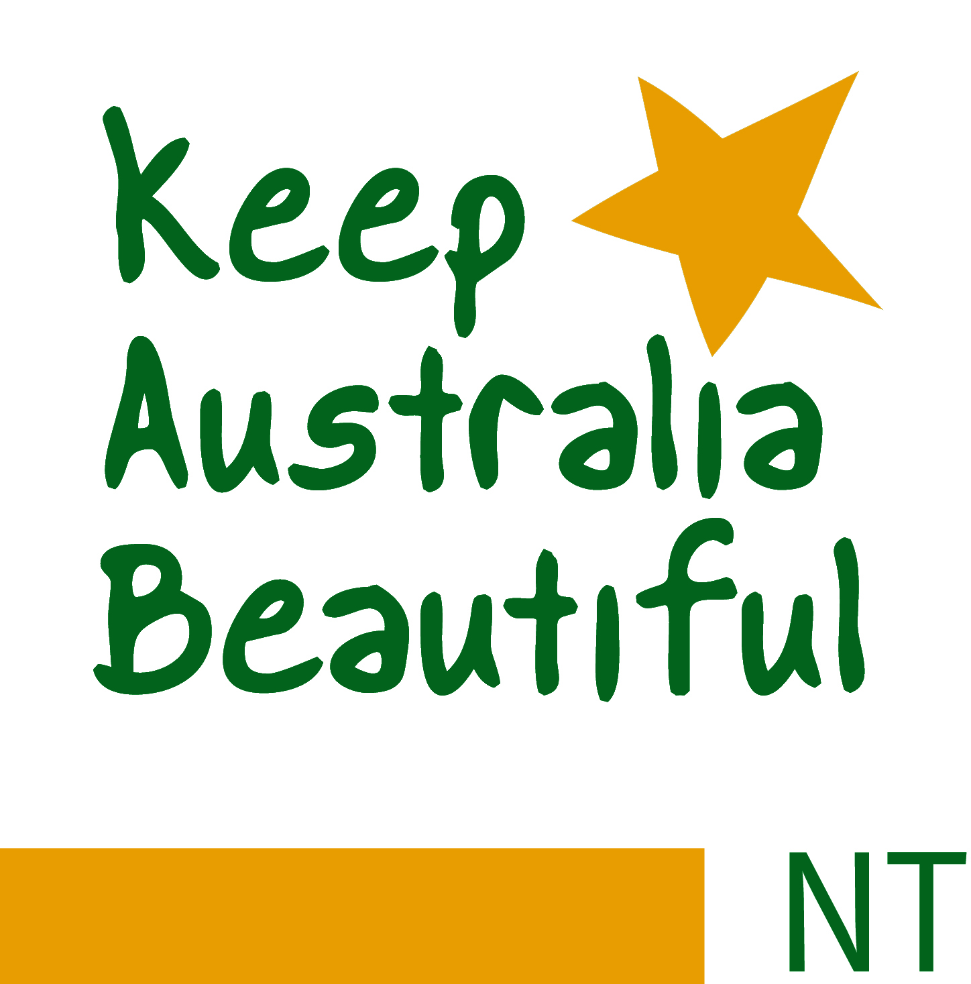

Be Tidy, Be Crocwise, and Be Responsible!

Keep Australia Beautiful Council NT has officially launched its 40th operational year as an association with Minister for Environment and Natural Resources, Lauren Moss, announcing the 2017 Territory Tidy Towns program as open for registration and community participation.

Minister Lauren Moss urged all Territorians to actively participate in keeping their communities clean and tidy by binning rubbish and by “picking up one piece of rubbish a day” which equated to 250,000 pieces of less ground litter.

The challenge was issued at the Territory Tidy Towns launch at Parliament House after cutting the cake to celebrate KABC(NT)’s 40th operational year as an association.

“Territory Tidy Towns program achieves social and environmental benefits within our major hubs and remote communities and our annual winner represents the Northern Territory at the national awards.”

“It builds pride, self esteem and respect and it also recognises and acknowledges efforts.”

KABC(NT) Chief Executive, Heimo Schober, said picking up one piece of rubbish a day was a small task that was “good for the soul” and of great benefit to the Territory.

“Territorians are just one percent of Australia’s population but we account for 10 percent of Australia’s litter, we need to do better.”

Be Crocwise category has been included this year again to encourage schools and acknowledge teaching efforts associated with crocodile safety and awareness. A large portion of Northern Territory Schools are within saltwater crocodile habitat and this category recognises schools that take steps to educate and actively ensure that students know how to be safe around Territory waterways while ensuring the ongoing survival of saltwater crocodiles.

Regional Councils, Communities and groups interested in participating can register their nomination with KABC(NT) until the end of September. The winners will be announced in October this year at a Tennant Creek gala dinner awards event.

For further information please contact
Keep Australia Beautiful Council NT, Chief Executive Officer, Heimo Schober
by phone 0407 186 461 or email to ceo@kabcnt.org.au

About Keep Australia Beautiful Council (NT): Keep Australia Beautiful Council NT is the Northern Territory’s peak body on litter prevention. With more than four decades of experience in engaging Territorians to care for their local environments, (not to be confused with Clean Up Australia Day) KABC(NT) Programs include Territory Tidy Towns, National Litter Index, Eco-Schools, Sustainable Cities, Clean Beaches, and Keep Australia Beautiful Week in August.

The KABCNT website is www.kabcnt.org.au where all information on the organisation can be accessed including membership, Eco-School program and the National Litter Index, which is Australia’s only independent nation-wide litter research.

