MEDIA RELEASE
28 November 2016

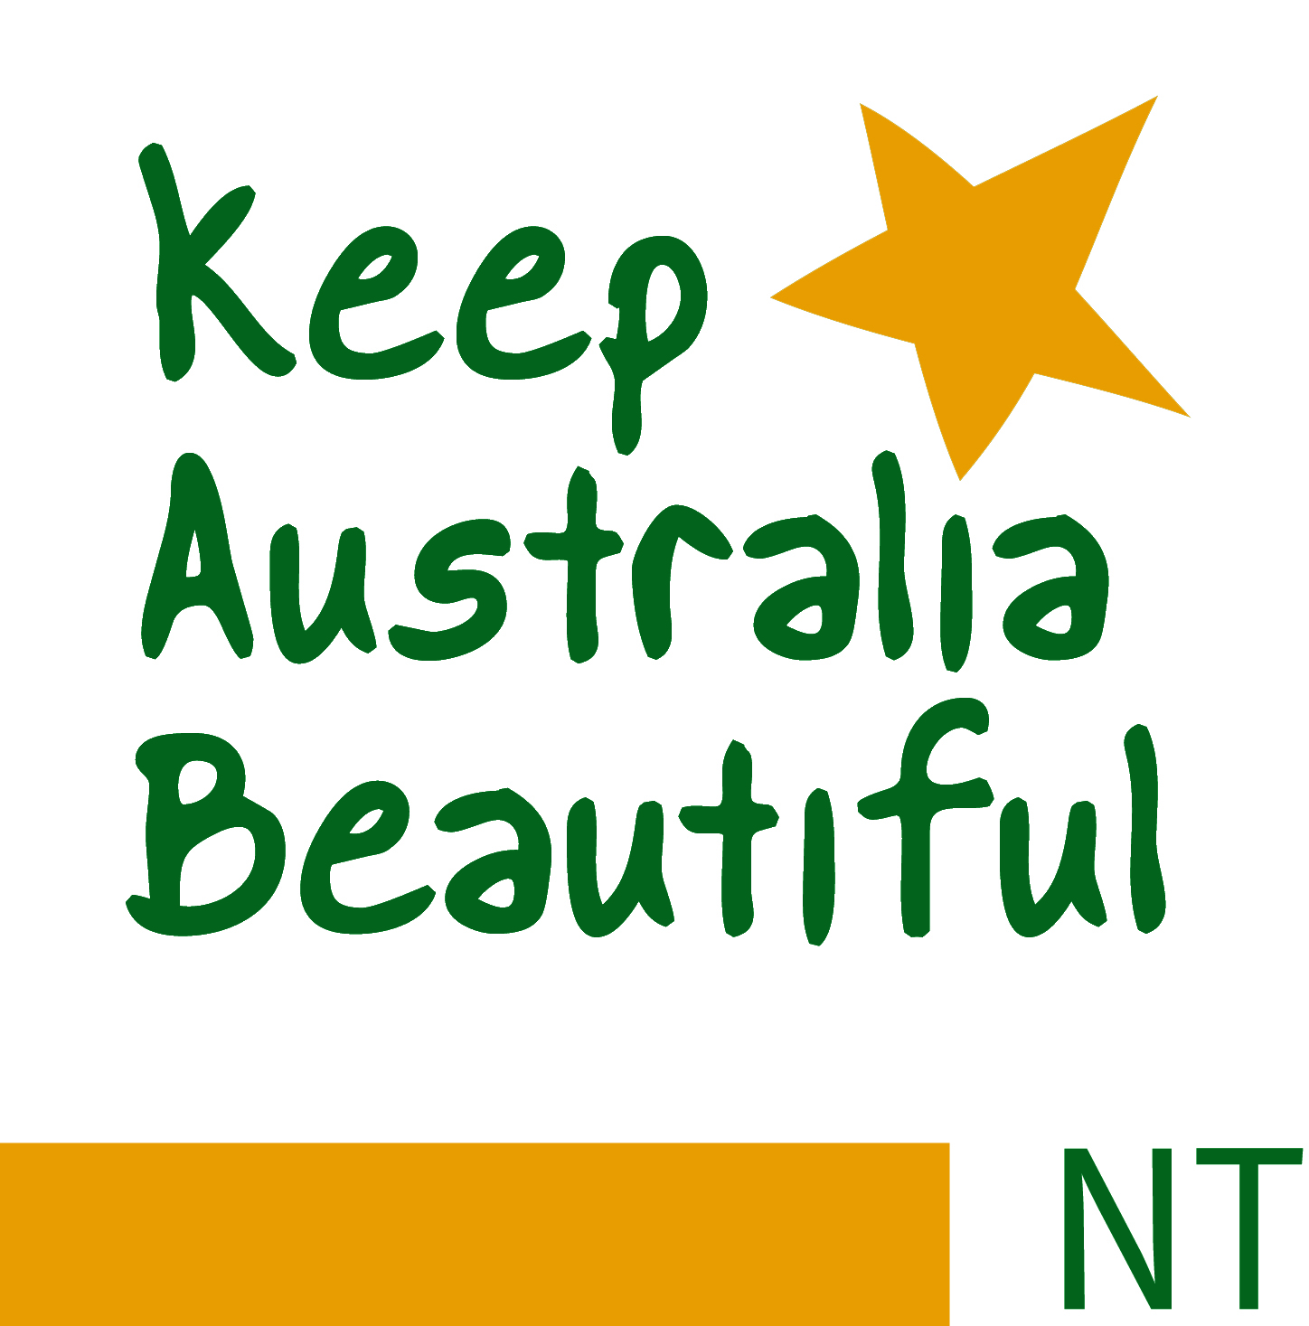

Inaugural BE CROCWISE Award

Humpty Doo Primary School All Stars Centre students were proud to be the first ever Territory school to receive the inaugural and very special ‘BE CROCWISE’ School Award, which was held in partnership with Parks and Wildlife Commission NT and Keep Australia Beautiful Eco-schools this year.

Over the past four terms, All Stars Centre students have completed curriculum linked BE CROCWISE activities and learned a great deal about crocodiles. The students created and delivered BE CROCWISE PowerPoint presentations for their peers and community, produced and displayed crocodile paintings and posters to create awareness, completed crocodile sculptures that were sold at their school fete, and participated in a School camping trip at Twin Hall Cattle Station, where the students put into practices their ‘BE CROCWISE’ education.

These activities and specific project works undertaken by the school students had led Humpty Doo Primary School All Stars Centre to be successful in taking out the Inaugural ‘BE CROCWISE’ Award presented by both the Northern Territory Government Minister the Honourable Lauren Moss and our Outback wrangler Matt Wright.

Saltwater crocodiles are an apex Territory predator, they are very important to our environment, Indigenous culture and our economy.

They do pose a risk to people living in ‘crocodile country’ and we all need to BE CROCWISE in areas where saltwater crocodiles live.

The BE CROCWISE award recognises and acknowledges Northern Territory Schools that are educating the dangers saltwater crocodiles pose. It awards schools that have taken steps to ensure that everyone in their community knows how to stay safe around Territory waterways, while still ensuring the survival of one of the most important animals in our environment.

Keep Australia Beautiful Council NT CEO Heimo Schober said that Humpty Doo Primary School All Stars Centre Students and Teachers had achieved these elements through a number of initiatives and strategies successfully introduced and implemented by the school this year.

“By schools teaching and learning the BE CROSWISE message, being responsible and positively taking ownership, the risk posed by crocodiles can be reduced dramatically,” Mr Schober said.

“Knowledge and respect for animals, environment, people and the country is vital to reducing risks associated with our crocodiles.

“Keep Australia Beautiful would like to sincerely congratulate Humpty Doo Primary School All Stars Centre on their BE CROCWISE achievements to date and their inaugural award win with of course bragging rights for the next 12 months.

“We’d encourage all Northern Territory schools to register on line with Eco-Schools and actively participate in the BE CROCWISE learning and actions.

“Be respectful to all and ‘Do the Right Thing,’ and if it saves just one life it’s certainly worth it,” Mr Schober said.

For further information please contact
Keep Australia Beautiful Council NT, Chief Executive Officer, Heimo Schober
by phone 0407 186 461 or email to ceo@kabcnt.org.au

About Keep Australia Beautiful Council Northern Territory: Keep Australia Beautiful delivers National Eco-School program which is a sustainable schools program with global accreditation and includes BE CROCWISE biodiversity in Northern Territory. Keep Australia Beautiful is the Territory’s peak body on litter prevention. With more than four decades of experience in engaging Territorians to care for their Country and local environments, (not to be confused with Clean Up Australia Day) KAB Programs include Sustainable Cities, Territory Tidy Towns, Clean Beaches, National Litter Index, Eco-Schools, and Keep Australia Beautiful Week in August.

The KABCNT website is www.kabcnt.org.au where all information on the organisation can be accessed including membership and the National Litter Index, which is Australia’s only independent nation-wide litter research.

