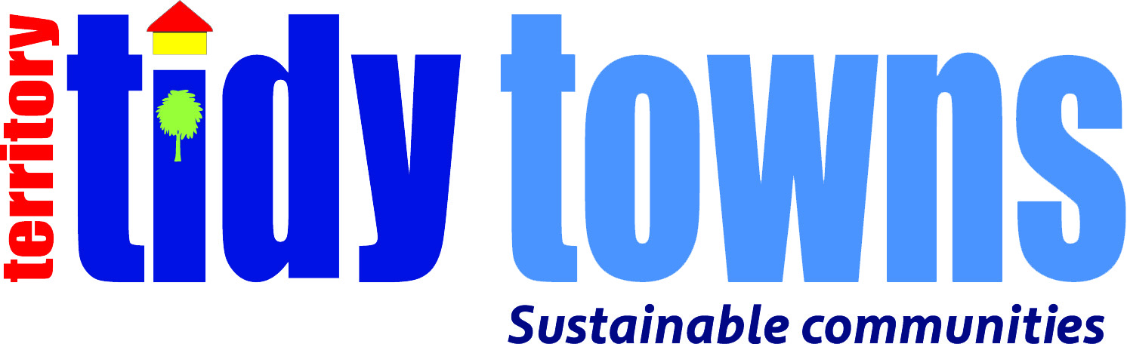

HOW TO ENTER

- Award launched at media event (Feb 2017).
- Entries called for (Category Award entrants & Tidy Towns Support entries).
- Entrants fax, mail and email entry forms and Award Support documents.
- Communities that aspire to be better and require Tidy Towns supportive ‘dot point plans’, fax or email entry form for your category specific support plans.
- All Entries lodged by return FAX, mail or email to Keep Australia Beautiful Council (NT) and to include:
  - Returned Tidy Towns ‘Self Assessment’ judges sheet (tick box format)
or
  - Text and images, relevant to each TTT category criteria
  - Text: no more than one page on each criteria please
  - Images: indexed; captioned for category/criteria
  - (photos in jpg or similar, close ups of participants appreciated)
  - Name, role/office, details of contact person included

CATEGORY CRITERIA

Suburb / Electorate / Community Participation
Actions and partnership achievements in community beautification, presentation and pride. Partnership achievements by communities with all levels of government and/or business, building better major hubs and remote community societies.

- Innovation
Innovative projects or practices that focus on social and ecological sustainability.

- Litter Control/Prevention
Achievement in community litter management and reduction of ground litter including the undertaking of litter audits, and litter education awareness programs. These activities will improve remote community social and environmental well being with a positive effect on health.

- Resource Recovery
Achievement in resource recovery and waste management including initiatives which conserve resources and encourage waste minimisation practices; the recovery of beverage containers for recycling, reuse of materials such as building materials, and the appropriate disposal of non-recyclable materials. These activities will achieve improved community environmental well being.

- Environmental Care (Innovation & Protection)
Achievements in innovative principles and actions associated with developing sustainable communities. Also achievements associated with the protection of the natural environment and, specifically, the preservation of native flora and fauna.

- Water Conservation
Sustainable water management achievements within communities which has combined innovative or new water conservation and water re-use initiatives at the private, industrial and municipal levels, benefiting society and nature.

- Energy Conservation
Achievements in sustainable energy management which focus on innovative or new energy efficient measures and climate change issues.

- Heritage & Culture
Community achievements which proudly preserve and value cultural history.

- Citizen & Youth Legends
Citizen and Youth initiatives which encourages and promotes community residential initiatives and environmental education with positive environmental and social outcomes.

- Be Crocwise
Recognises and acknowledges community efforts to teach and learn Be Crocwise key message taking ownership and responsibility to reduce risks associated with crocerdiles.

- Best House/Street (Actions & Activities)
House or Community Street actions and activities that focuses on home and street beautification and pride, delivering continuous improvements towards social and environmental development.

Northern Territory’s Tidiest Towns
Judges assess the communities against a range of criteria, including community pride and partnerships with government or business, innovative projects or practices that focus on ecological sustainability, litter management, resource recovery and waste management, energy minimisation and protection of the natural environment.

The winner will be the Territory community which best exemplifies all of the elements of the judging criteria.

Importantly, when selecting finalists, judges are required to take into account each community’s geographic, environmental, economic and cultural circumstances, and to assess how efficiently and effectively the community uses the resources available to it.

JUDGING

A judging panel will review all entries (judging criteria available at any time).

TIMING

- Award launched February 2017
- Entrants judged up through to mid October 2017
- 25th Oct 2017 Northern Territory Finalists and National Representative announced
- March 2017 Australian Tidiest Towns Awards – NT Finalist representing our Territory

AWARD SPONSORS

The Northern Territory Tidiest Towns Award 2017 is conducted by Keep Australia Beautiful Council (NT) and is sponsored by:

- Northern Territory Government

The Territory’s Tidiest Towns Awards conducted by Keep Australia Beautiful is sponsored by:

- Northern Territory Government (NTEPA) is a major supporter of Keep Australia Beautiful Council Northern Territory and the Territory Tidy Towns program.
  - The Territory Government and its various Departments have key ‘shared’ objectives with Keep Australia Beautiful (NT). They have shared visions with the local ‘Territory’ community and are seriously committed to continuous improvement through community social and environment development. The Northern Territory Government, as a long term partner, regularly funds KABC(NT) community based programs and proudly supports and assists in creating community awareness of our flagship Territory Tidy Towns program, encouraging engagement and participation, creating sustainable ownership and responsibility.

Regards
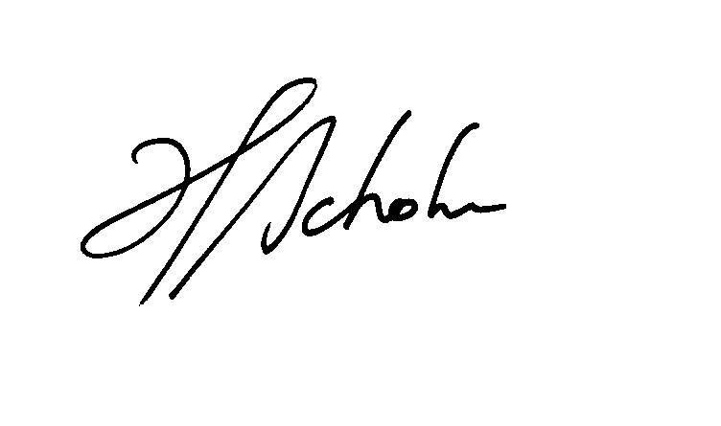Heimo Schober CEO, Keep Australia Beautiful Council (NT)
ceo@kabcnt.org.au Ph 08 8981 5535 Fax 08 8981 9719 Mobile 0407 186 461

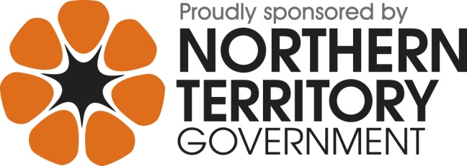
“Sponsored by the Northern Territory Government through the Northern Territory Environment Protection Authority”

