HOW SCHOOLS CAN ENTER

- Program Awards launched at media event (Feb 2017).
- Entries called for (Category Award entrants & Tidy Towns Support entries).
- Entrants scan, email fax, and mail entry forms and Award Support documents.
- Schools aspiring to be better and want Tidy Towns supportive ‘dot point plans’, email or fax entry form with request for your category specific support plans.
- All Entries lodged by return email, scan, fax or mail to Keep Australia Beautiful Council (NT) and to include:
  - Returned Tidy Towns ‘Self Assessment’ judges sheet (tick box format)
or
  - Text and images, relevant to each TTT category criteria
  - Text: no more than one page on each criteria please
  - Images: indexed; captioned for category/criteria
  - (photos in jpg or similar, close ups of participants appreciated)
  - Name, role/office, details of contact person included

CATEGORY CRITERIA

- School Community Participation
School actions and partnership achievements in combined community health, beautification, presentation and pride. Partnership achievements by school communities with all levels of government and/or business, building better major hubs and remote community societies.

- Innovation
Innovative projects or practices that focus on social and ecological sustainability.

- Litter Control/Prevention
Achievement in school community litter management and reduction of ground litter including the undertaking of litter audits, making anti-litter posters and delivering litter education awareness programs. These activities will improve remote community social and environmental well being with a positive effect on health.

- Resource Recovery
Achievement in resource recovery and waste management including initiatives which conserve resources and encourage waste minimisation practices; the reuse of paper and cardboards, recovery of beverage and other containers for recycling, reuse of other school materials such as building materials, and the appropriate disposal of non-recyclable materials. These activities will achieve improved community environmental well being.

- Environmental Care (Innovation & Protection)
Achievements in innovative principles and actions associated with developing sustainable school communities. Also achievements associated with the protection of the natural environment and, specifically, the preservation of native flora and fauna.

- BE CROCWISE (Safety & Education)
Recognition and acknowledgement for Schools that have taken steps to educate and actively ensure that everyone in their community knows how to be safe around Territory waterways while ensuring the ongoing survival of Saltwater crocodiles.

- Water Conservation
Sustainable water management achievements within school communities which has combined innovative or new water conservation and water re-use initiatives at the classroom, school grounds and community municipal levels, benefiting society and nature.

- Energy Conservation
Achievements in sustainable energy management within school community which focus on innovative or new energy efficient measures and climate change issues.

- Heritage & Culture
School Community achievements which proudly preserve and value cultural history.

- Citizen & Youth Legends
Citizen and Youth initiatives which encourages and promotes social initiatives and environmental education with positive environmental and social outcomes.

Northern Territory’s Tidiest School
Judging assesses the school community against a range of criteria, including school pride and partnerships with other agencies or business, innovative educational projects or practices that focus on ecological sustainability, litter management, resource recovery and waste management, water conservation, energy minimisation, biodiversity and protection of the natural environment.

The winner (or winners) will be the Territory school (or schools) which best exemplifies all of the elements of the judging criteria.

Importantly, when selecting finalists, judges are required to take into account each community’s geographic, environmental, economic and cultural circumstances, and to assess how efficiently and effectively the school community uses the resources available to it. There can be a northern school and southern school award recipients.

JUDGING

A judging panel will review all entries and judging forms (judging criteria available at any time).

TIMING

- Award launched February 2017
- School entrants judged up through to early October 2017
- 20th ^{t} Oct 2017 Northern Territory winning schools are announced

AWARD SPONSORS

The Northern Territory Tidiest Towns Award 2017 is conducted by Keep Australia Beautiful Council (NT) and is sponsored by:

- Northern Territory Government
- Wrigley (Mars Incorporated)
The Territory Tidiest Towns Awards are conducted by Keep Australia Beautiful and are proudly sponsored by:

- Northern Territory Government is a major supporter of Keep Australia Beautiful Council Northern Territory and the Territory Tidy Towns program.
The Territory Government and its various Departments have key ‘shared’ objectives with Keep Australia Beautiful (NT). They have shared visions with the local ‘Territory’ community and are seriously committed to continuous improvement and sustainability through community education, social and environment development. The Northern Territory Government, as a long term partner, regularly funds KABC(NT) community based programs and proudly assists in creating community awareness of our flagship Tidy Towns program, encouraging participation.

- Wrigley (Mars Incorporated) a partner and Major Sponsor of The Territory School’s Tidy Towns Awards & Forum Program for 2017. To further demonstrate Wrigley’s (Mars) commitment towards product stewardship ‘Litter Control’ and ‘Resource Recovery’, for sustainable communities, social and environmental development, Wrigley’s (Mars) are proudly supporting Keep Australia Beautiful and working together towards creating ownership and responsibility, jointly providing a clear, concise and social message to the communities of Northern Territory, and help deliver a better quality of life and a sustainable Australian environment for generations to come.

Regards
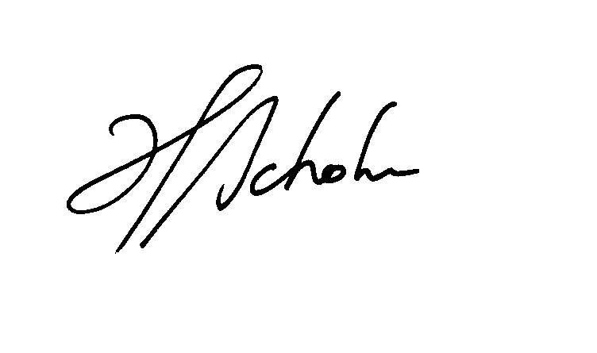
Heimo Schober CEO
Keep Australia Beautiful Council (NT)
ceo@kabcnt.org.au Ph 08 8981 5535
Fax 08 8981 9719 Mobile 0407 186 461
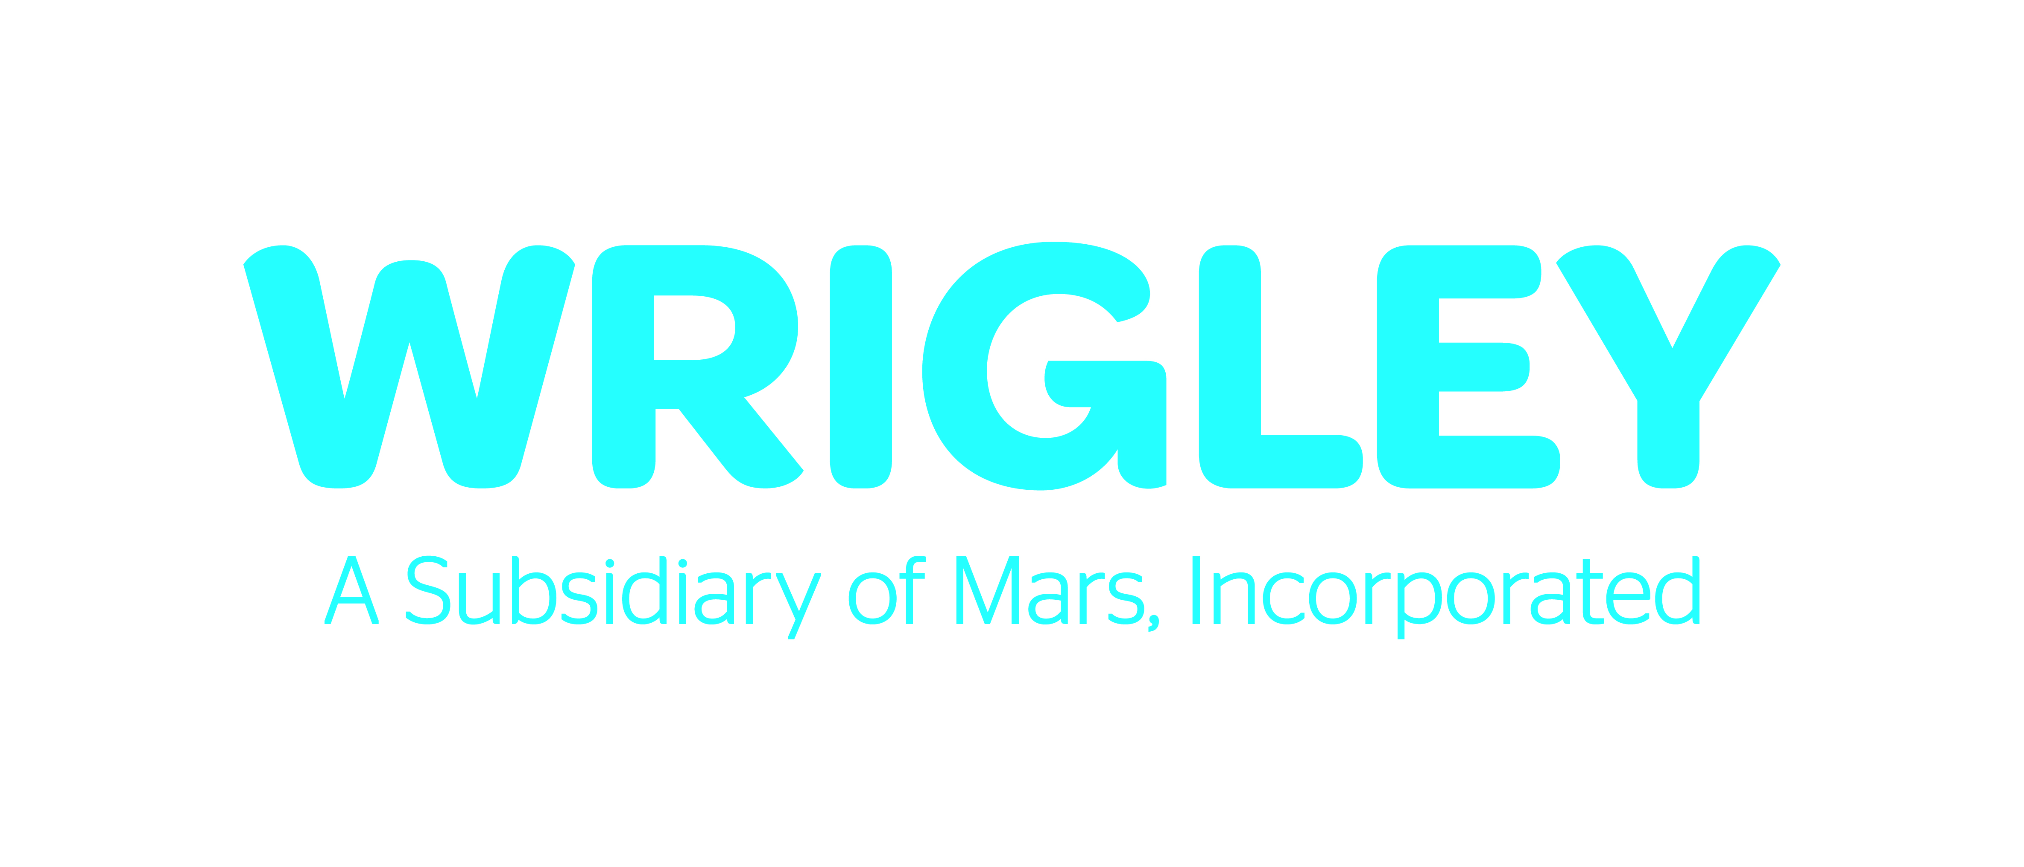
“Sponsored by the Northern Territory Government through Environment Protection Agency”

